Auto Ticket Classification using Flow Designer

Navigation Search – Update Sets
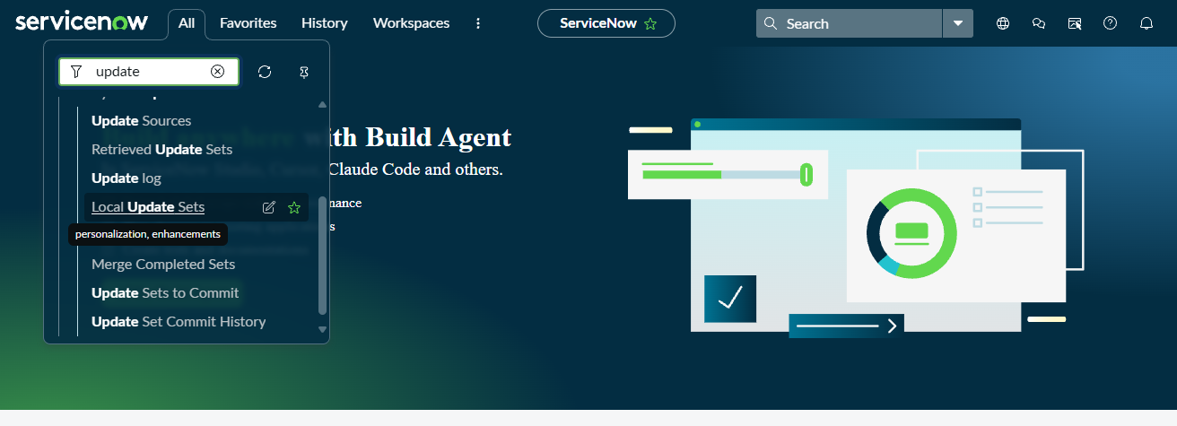
Local Update Sets List
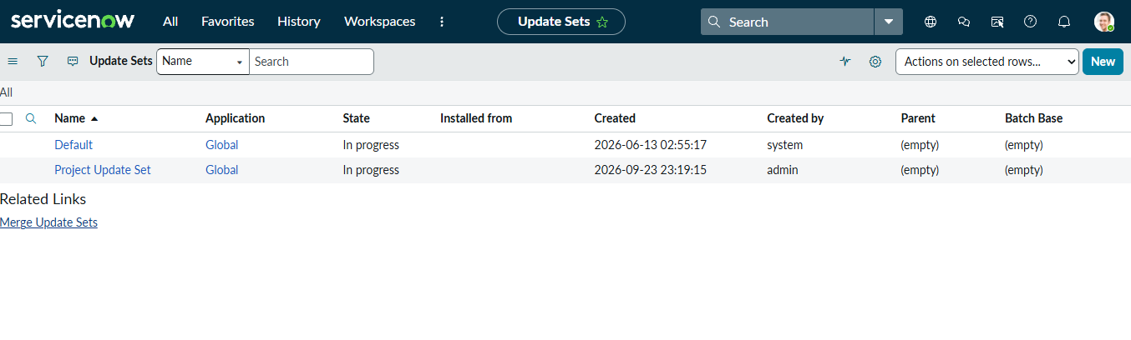
Created Update Set Details
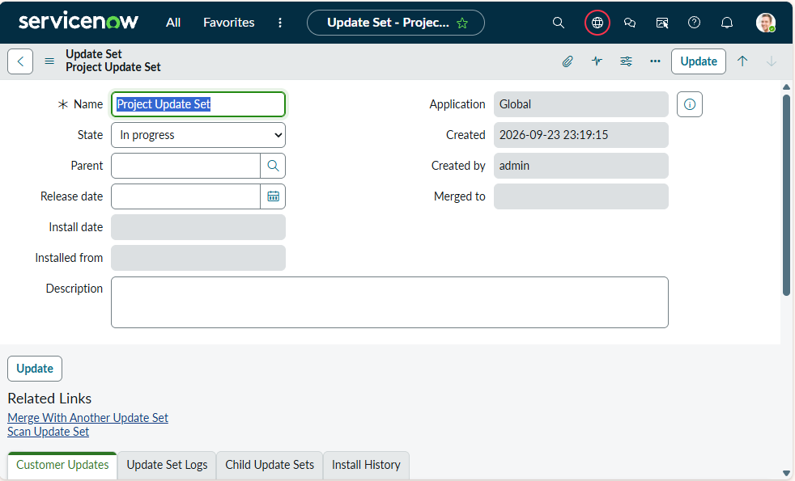

Category Choice Configuration
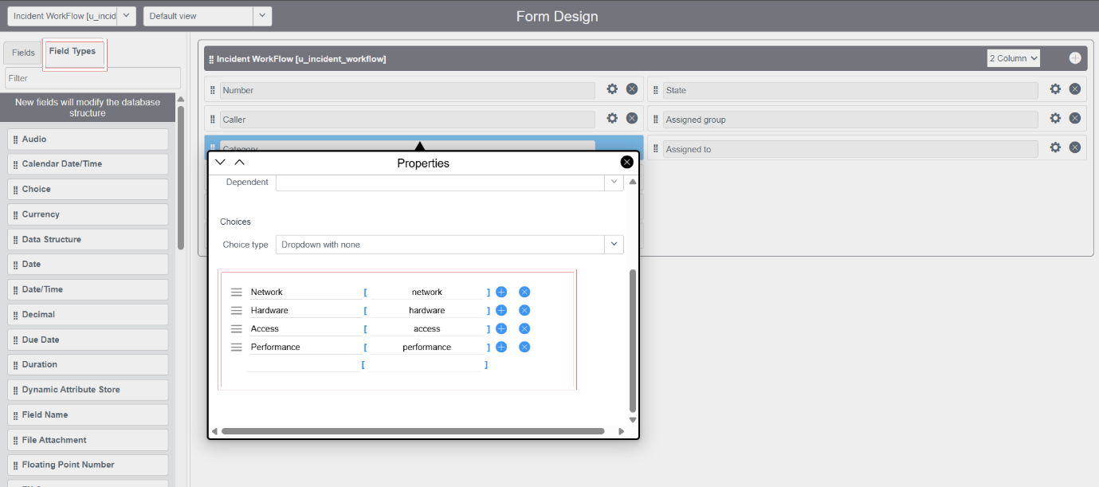

Subcategory Choice Configuration
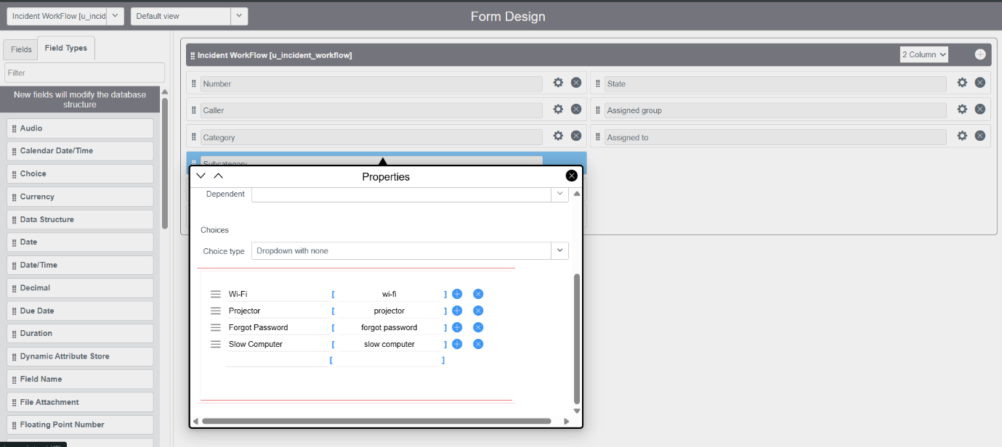
Configure Dictionary for Incident Workflow
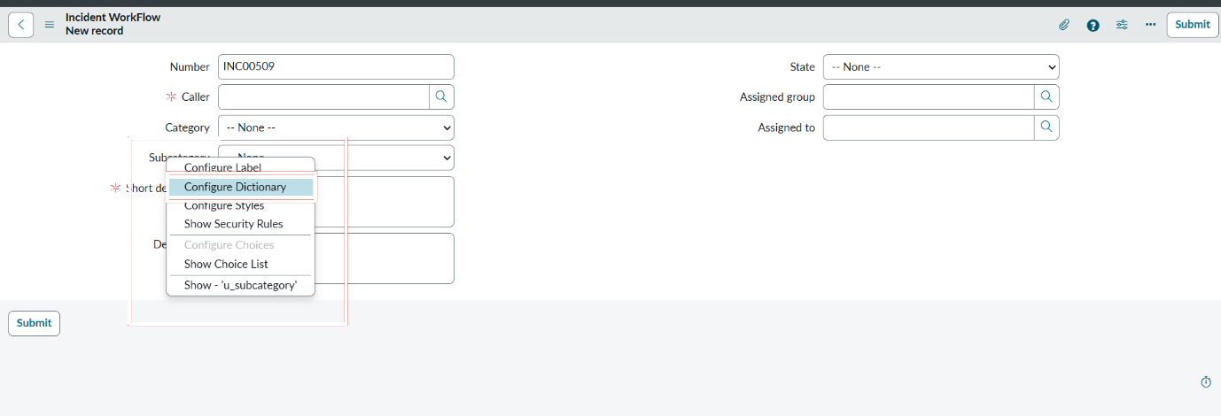
Subcategory Dictionary Entry – Dependent on Category
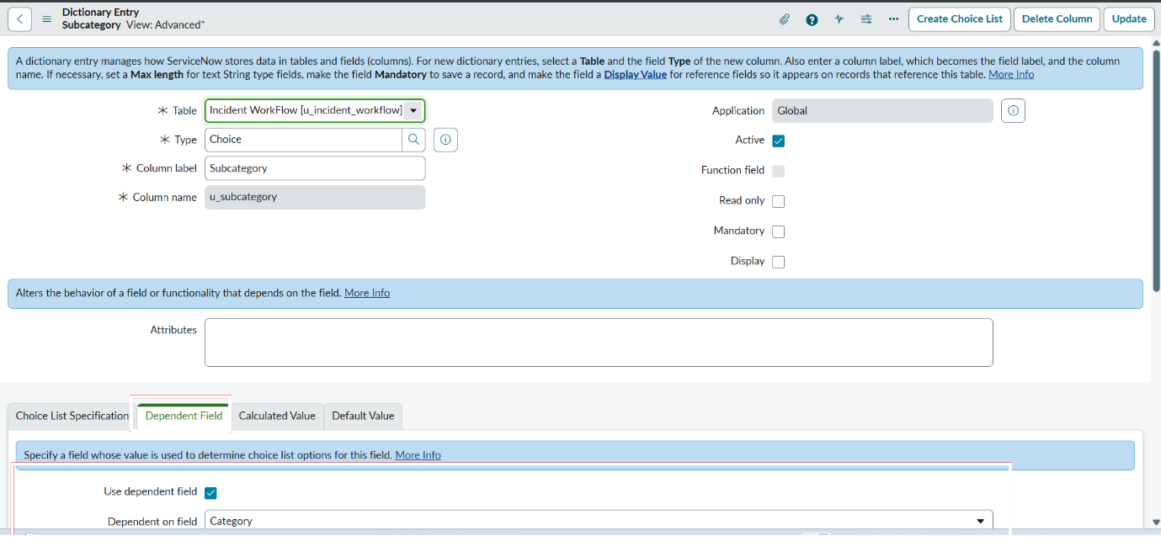
Subcategory Choice List Configuration
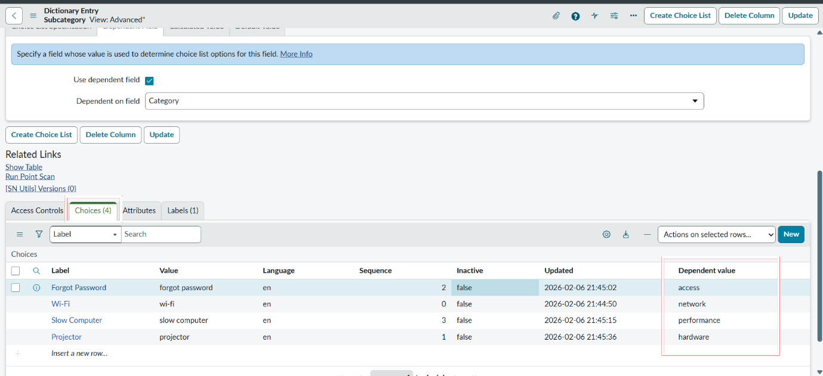
Incident Workflow – Network Category Selection
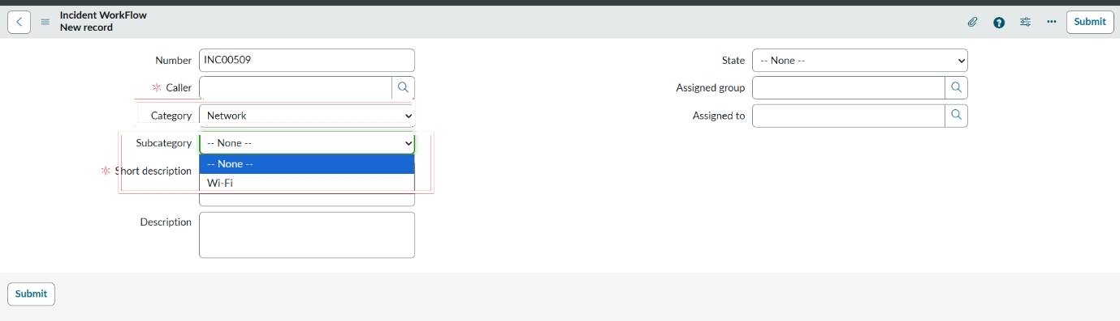

Hardware Category – Projector Subcategory
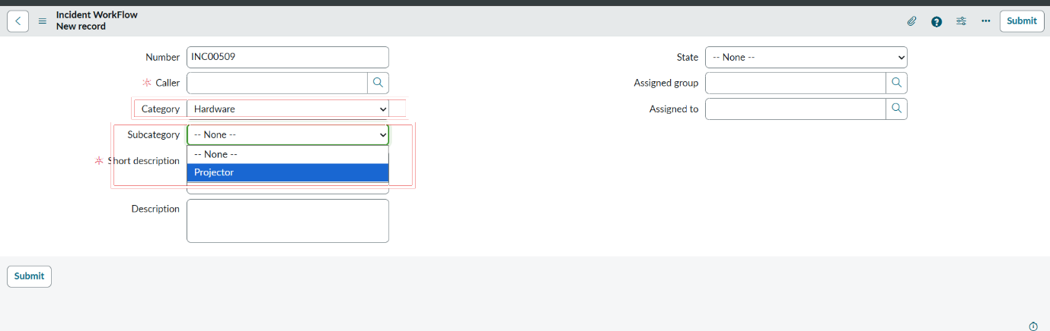
Performance Category – Slow Computer Subcategory
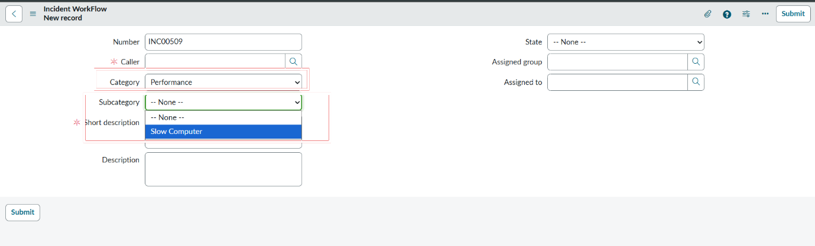
Access Category – Forgot Password Subcategory
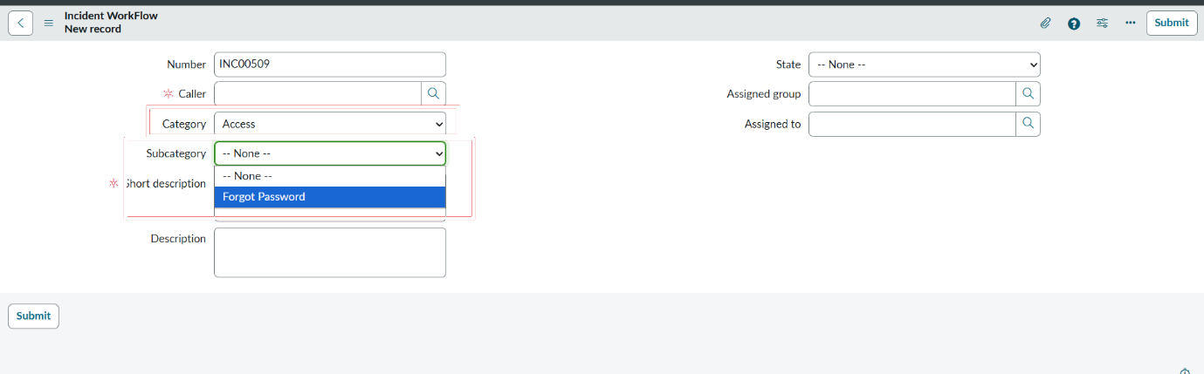

School IT Ticket Table Configuration
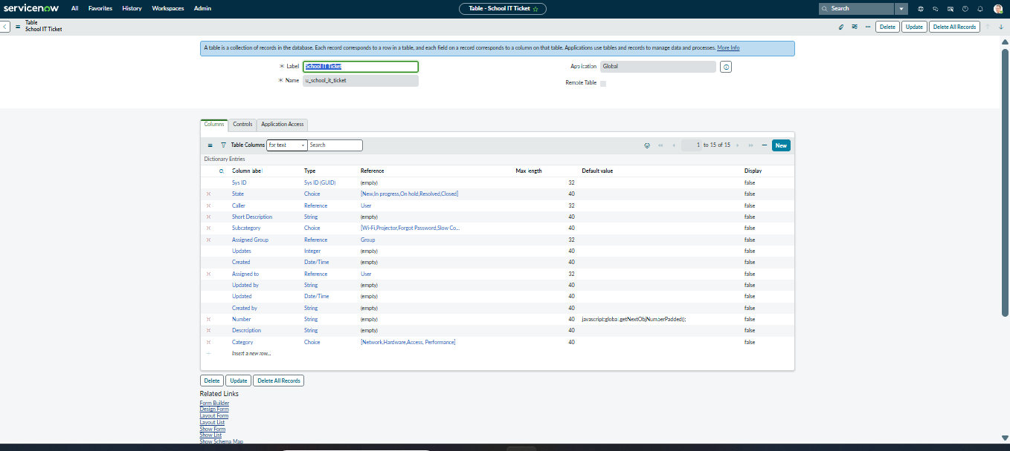

Navigation Search – Flow Designer
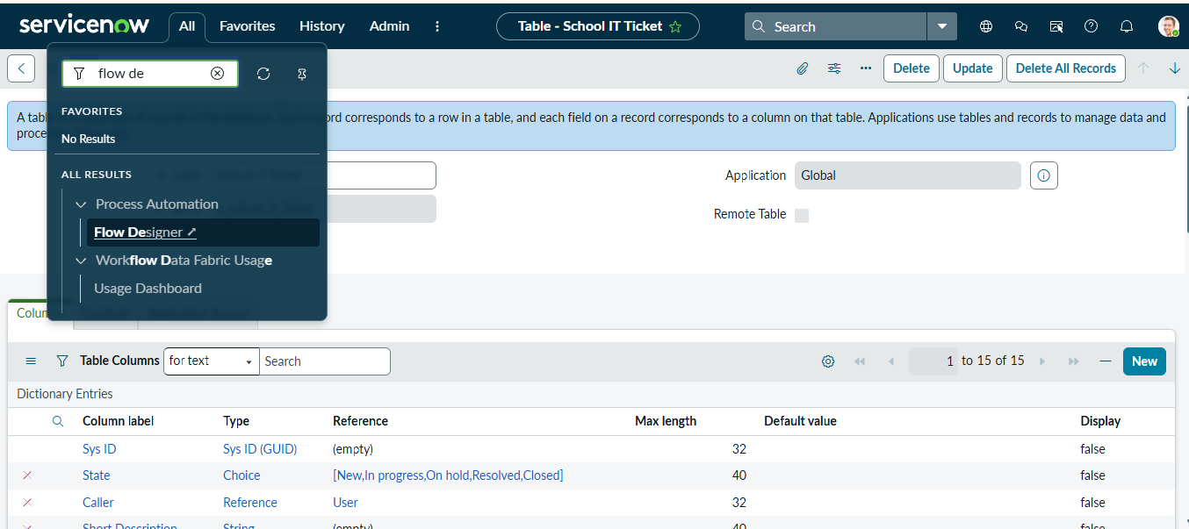

Workflow Studio – Create New Flow
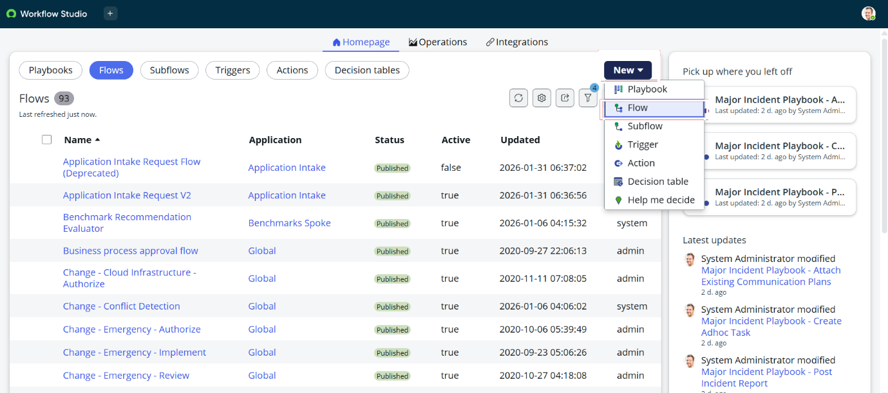

Auto Classify School IT Tickets – Flow Overview
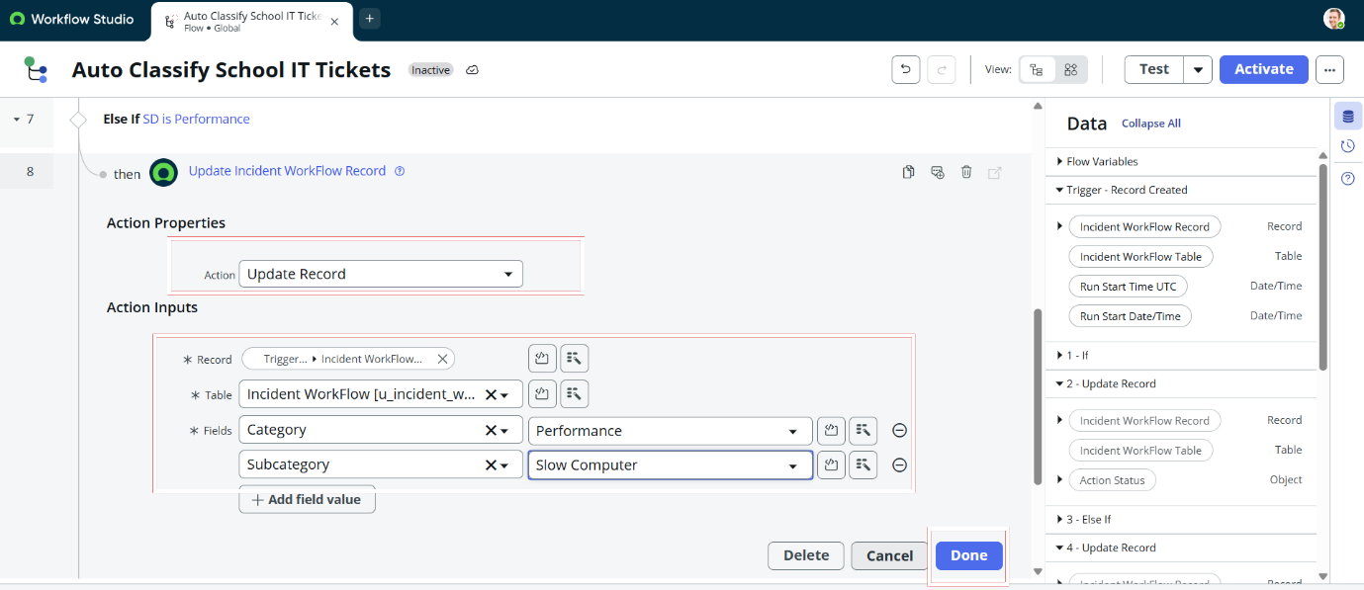

Flow Trigger – Incident Workflow Record Created
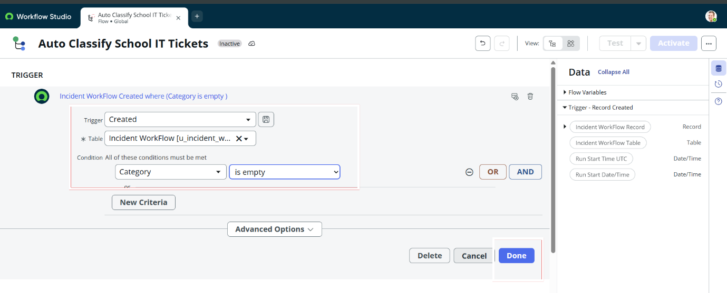

Wi-Fi / Network Condition Configuration
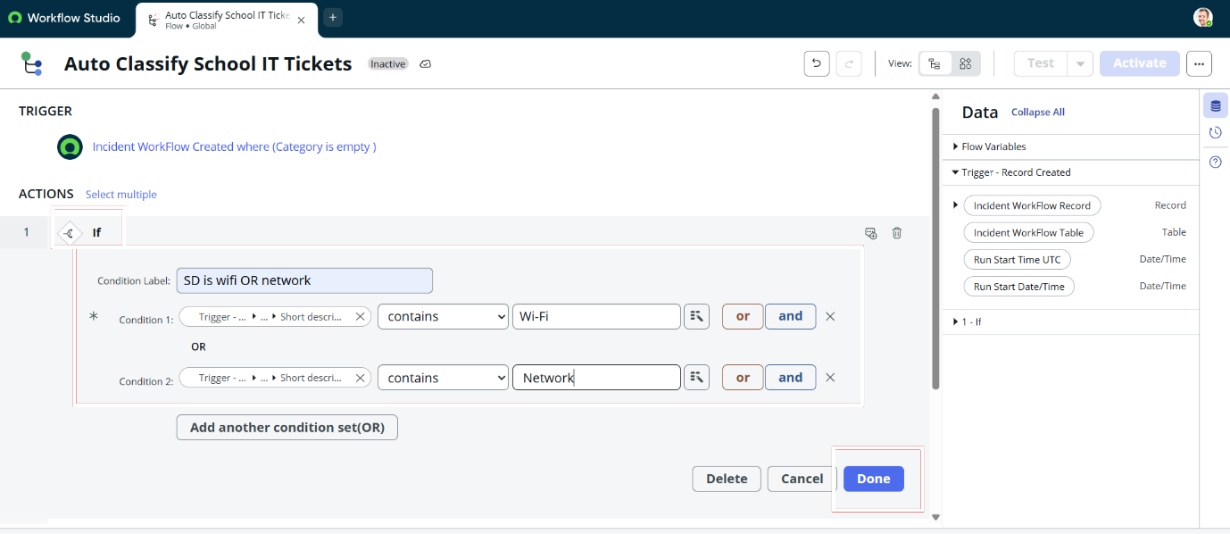

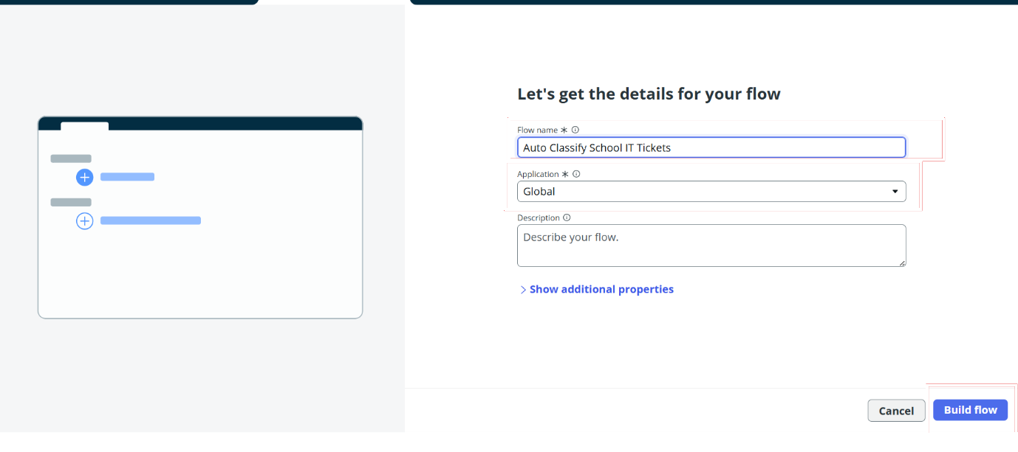
Flow Details – Auto Classify School IT Ticket

Update Record Action – Network / Wi-Fi Ticket
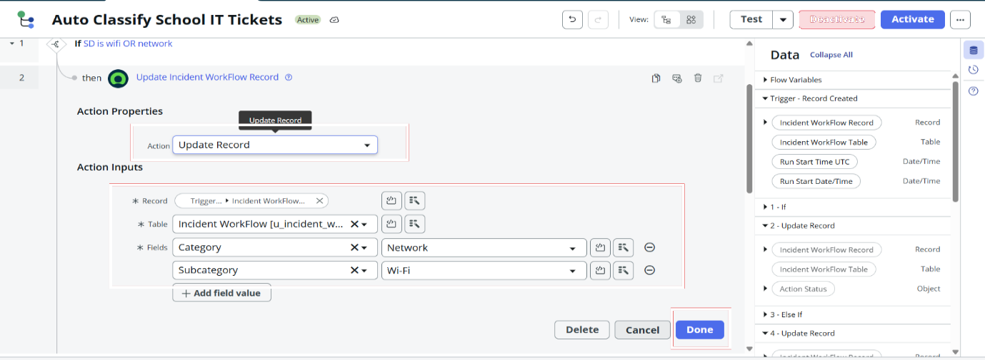

Forgot Password Condition Configuration
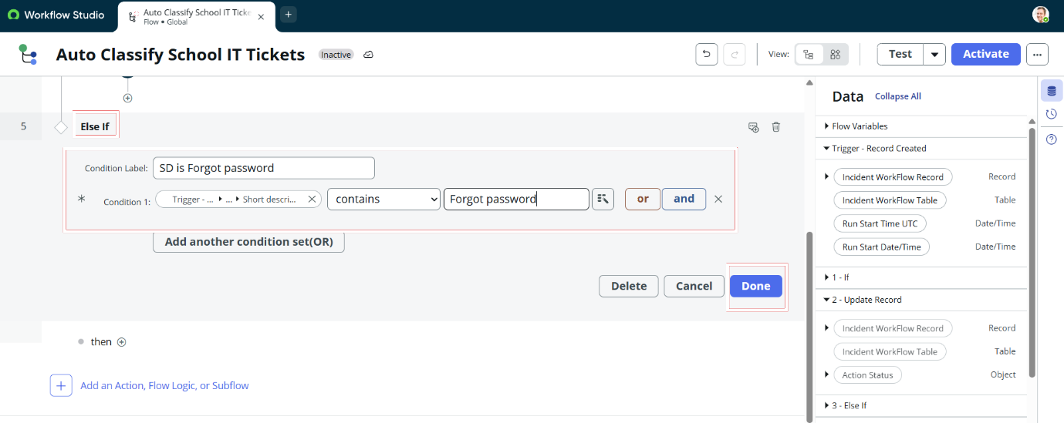

Update Record Action – Forgot Password Ticket

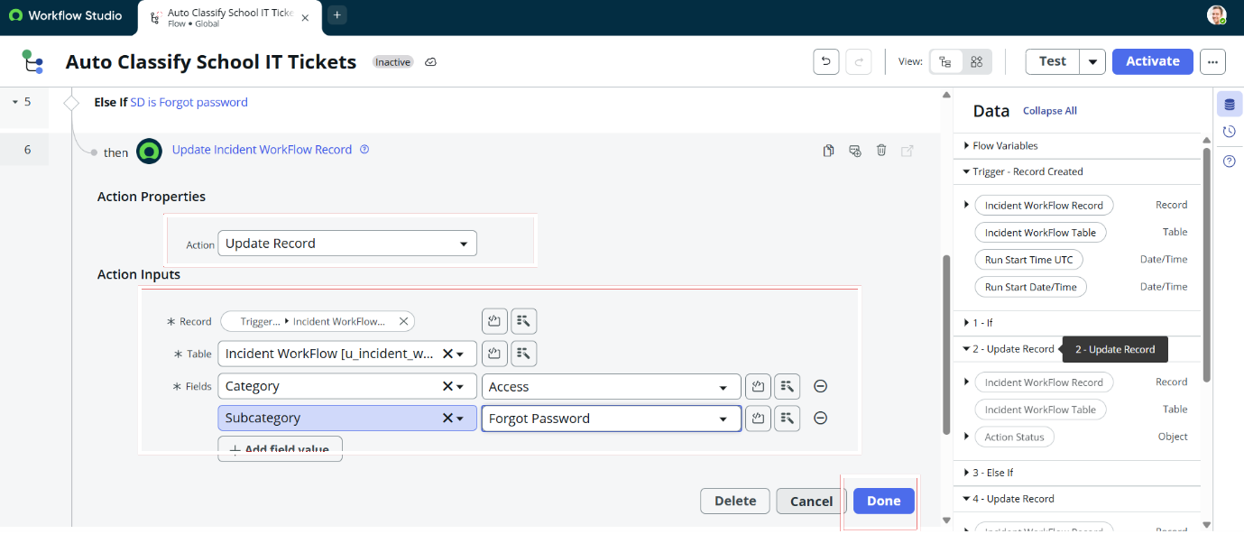
Send Email Action Configuration 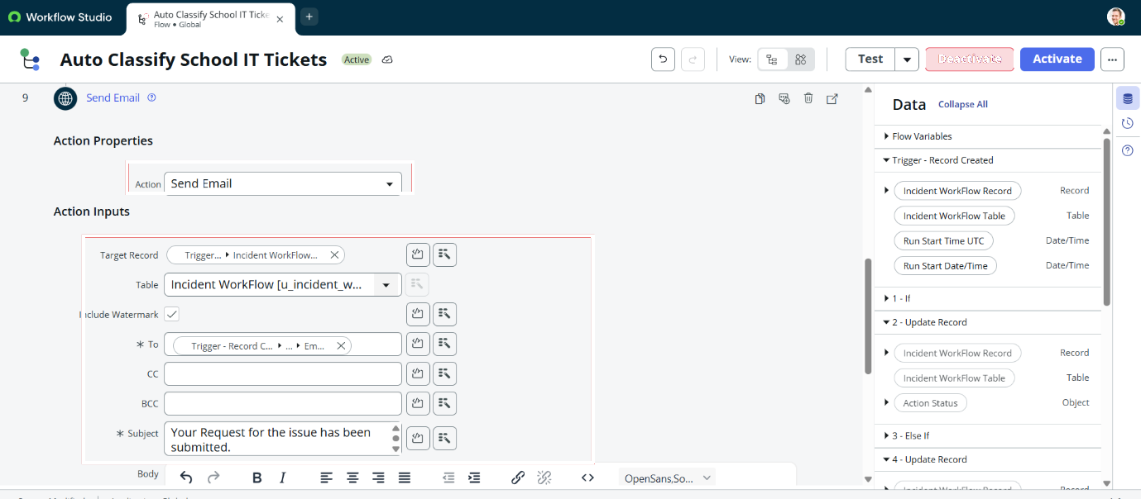

Slow Computer Condition Configuration
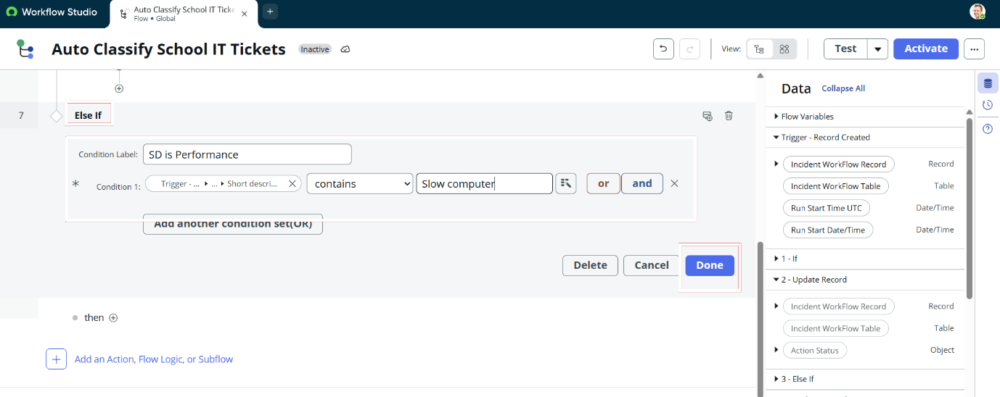

Update Record Action Properties
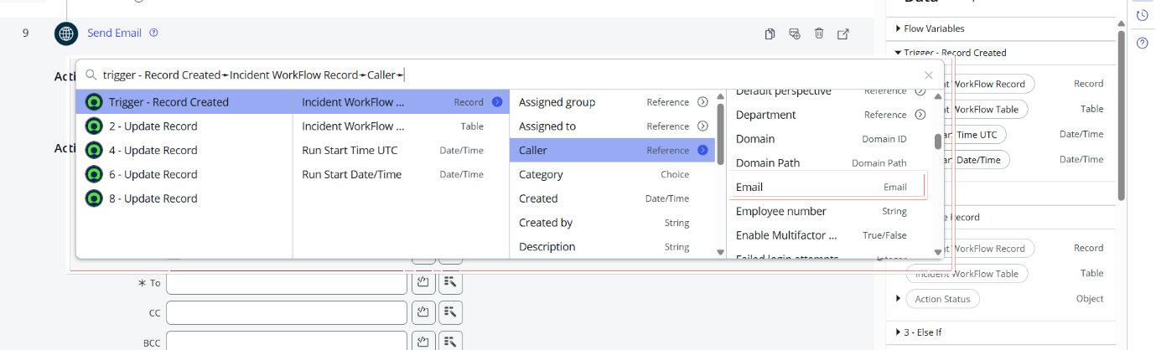

Network Ticket – Automated Classification Result

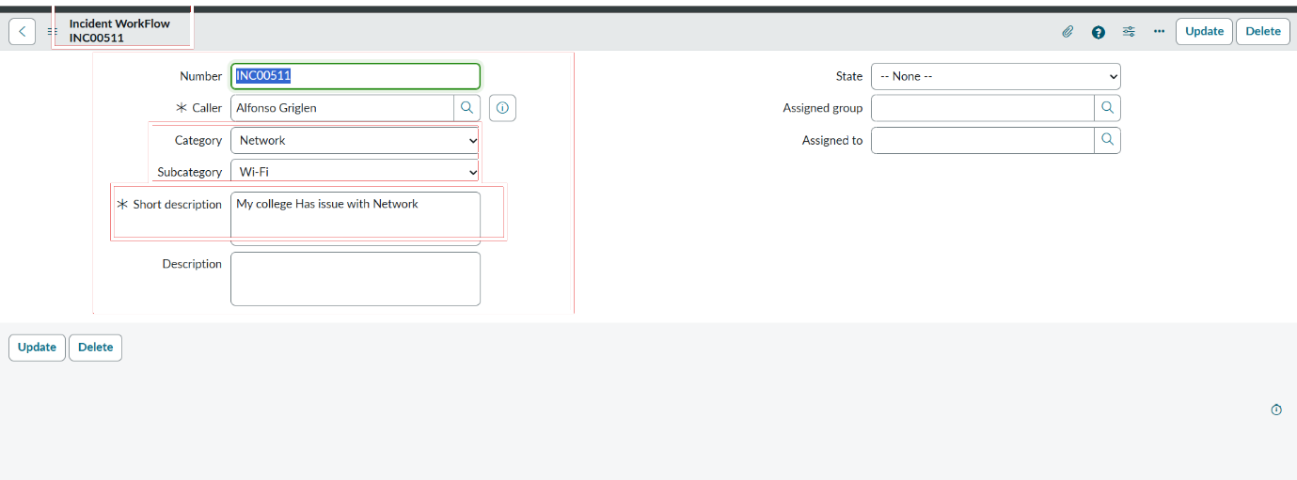
Email Notification Preview
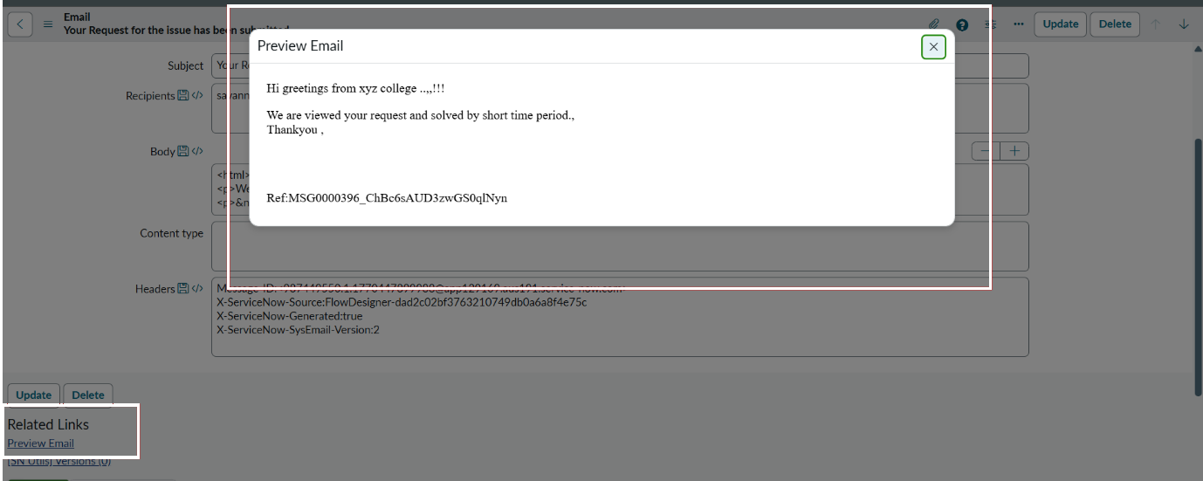
Hardware Ticket – Automated Classification Result

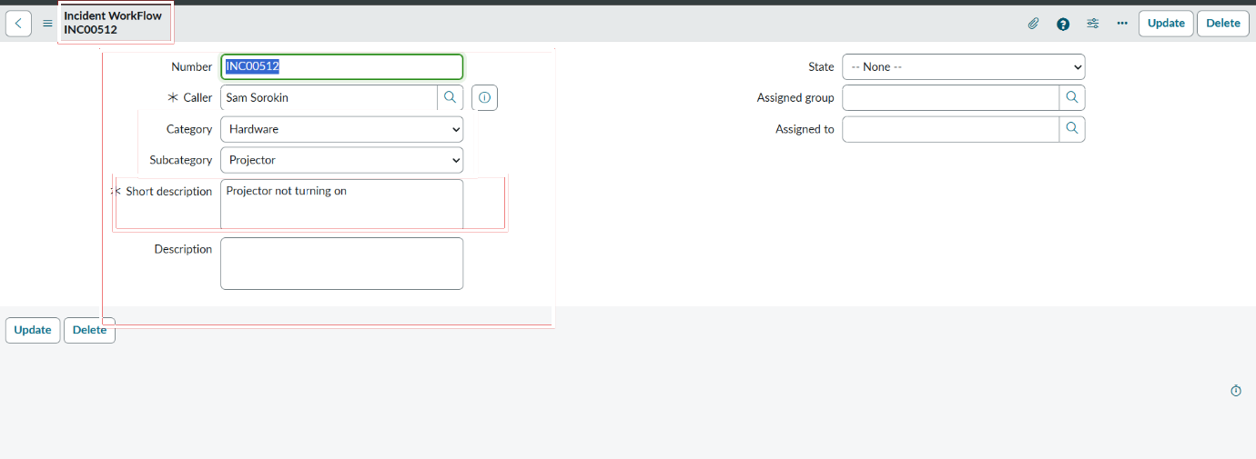

Project Update Set Details
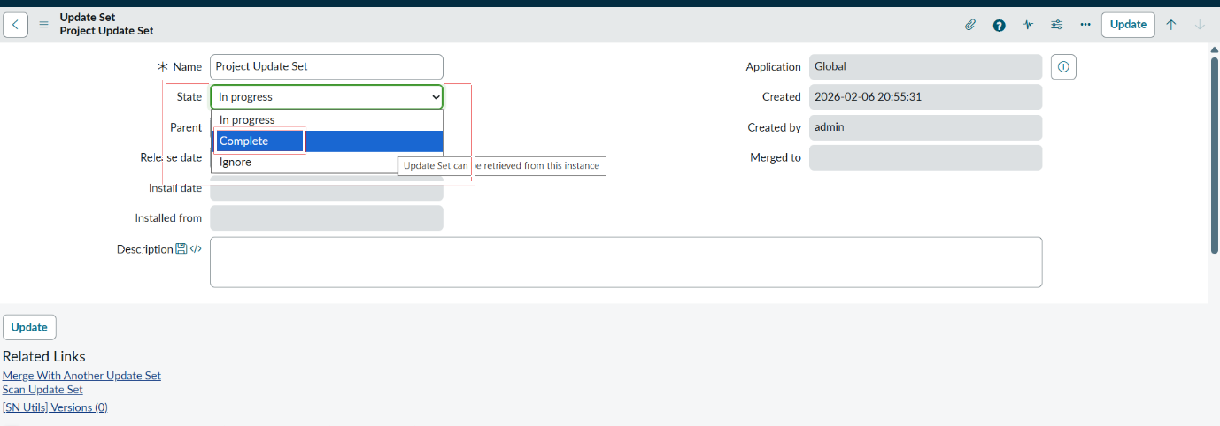
Completed Project Update Set
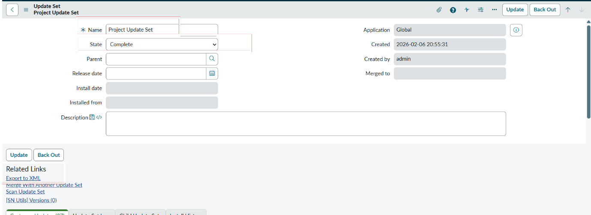

Update Set XML Download

